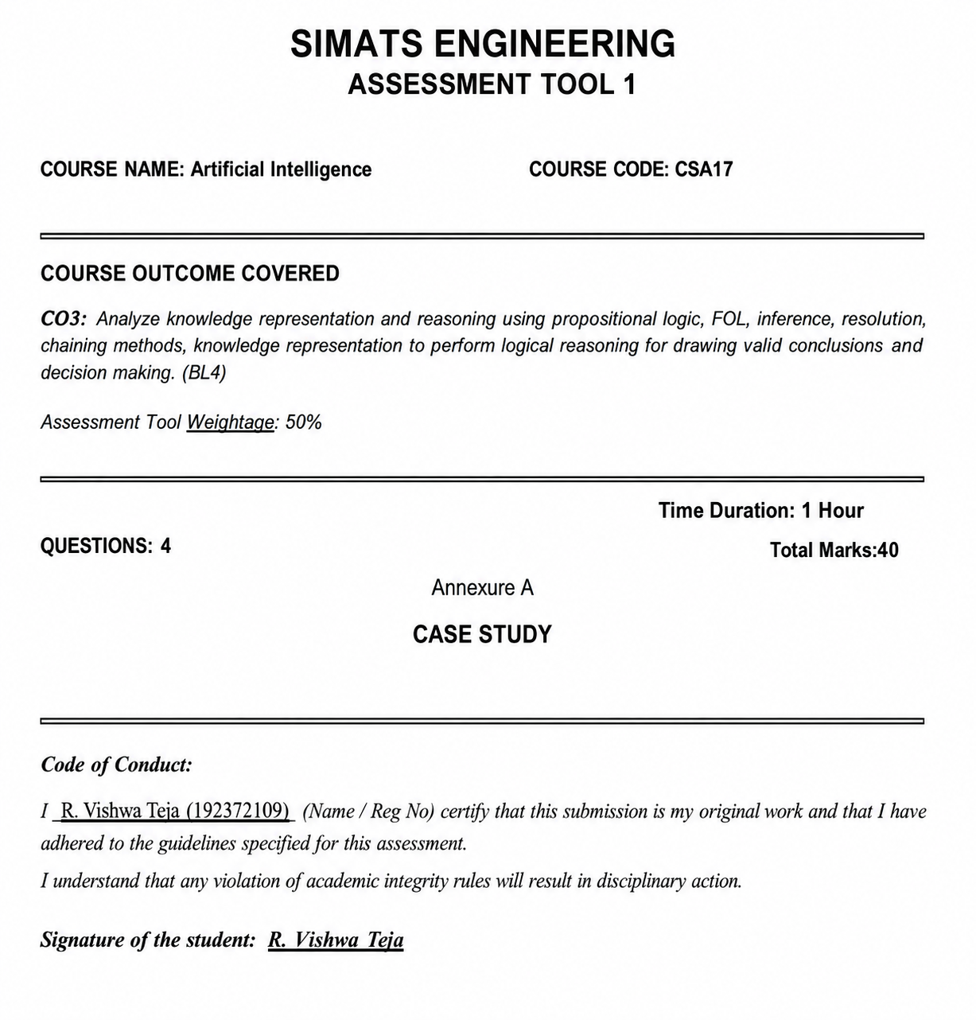

CASE STUDY 1 – SMART MEDICAL DIAGNOSIS SYSTEM
(a) Propositional Logic Representation
Let:
- F = Patient has Fever
- C = Patient has Cough
- R = Patient has Rash
- B = Patient has Breathlessness
- Flu = Possible Flu
- Measles = Possible Measles
- Pneumonia = Possible Pneumonia
Rules
1. Fever AND Cough → Possible Flu
F ∧ C → Flu
2. Fever AND Rash → Possible Measles
F ∧ R → Measles
3. Cough AND Breathlessness → Possible Pneumonia
C ∧ B → Pneumonia
Facts of Patient A
F = True
C = True
B = True
R is not given.
(b) Forward Chaining
Forward Chaining starts with the known facts and applies rules to derive new facts.
Step 1
Facts: F = True, C = True, B = True
Rule 1: F ∧ C → Flu
Since Fever and Cough are true: Flu = True
Step 2
Rule 2: F ∧ R → Measles
Rash is not given.
Therefore: Measles cannot be derived.
Step 3
Rule 3: C ∧ B → Pneumonia
Cough and Breathlessness are true.
Therefore: Pneumonia = True
Final Conclusions
- Possible Flu = True
- Possible Pneumonia = True
- Possible Measles = Cannot be concluded
(c) Backward Chaining for Pneumonia
Goal: Pneumonia
To prove Pneumonia, find a rule whose conclusion is Pneumonia.
C ∧ B → Pneumonia
Therefore, subgoals are: Cough AND Breathlessness
Pneumonia
|
Cough AND Breathlessness
/ \
Cough Breathlessness
✓ ✓
Both facts are available for Patient A.
Therefore: Pneumonia is proved.

CASE STUDY 2 – AUTONOMOUS TRAFFIC MANAGEMENT AGENT
The case uses First-Order Logic (FOL).
(a) Unification
Rule 1
∀x: Vehicle(x) ∧ EmergencyType(x) → ClearPath(x)
Given facts:
- Vehicle(Ambulance)
- EmergencyType(Ambulance)
We substitute: x = Ambulance
Therefore the substitution set is: θ = {x / Ambulance}
After substitution: Vehicle(Ambulance) ∧ EmergencyType(Ambulance)
Both facts are true.
Therefore: ClearPath(Ambulance)
MGU: θ = {x → Ambulance}
(b) Resolution Method
Goal: Proceed(CarA)
Relevant facts:
- Vehicle(CarA)
- Behind(CarA, Ambulance)
- Vehicle(Ambulance)
- EmergencyType(Ambulance)
Rule 1
Vehicle(x) ∧ EmergencyType(x) → ClearPath(x)
CNF: ¬Vehicle(x) ∨ ¬EmergencyType(x) ∨ ClearPath(x)
Using Vehicle(Ambulance) and EmergencyType(Ambulance), we derive:
ClearPath(Ambulance)
Rule 2
ClearPath(x) → GreenSignal(x) ∧ ¬RedSignal(x)
Therefore: GreenSignal(Ambulance)
Rule 3
Vehicle(x) ∧ Behind(x,y) ∧ GreenSignal(y) → Proceed(x)
Substitute: x = CarA, y = Ambulance
- Vehicle(CarA) ✓
- Behind(CarA, Ambulance) ✓
- GreenSignal(Ambulance) ✓
Therefore: Proceed(CarA)
Final Result: Proceed(CarA) is TRUE.
(c) Two Simultaneous Emergency Vehicles
The current knowledge base can handle individual emergency vehicles because the rules use ∀x.
However, to properly handle two simultaneous emergency vehicles, the KB should contain:
- Facts identifying both vehicles as emergency vehicles.
- Their positions or routes.
- Rules for prioritizing emergency vehicles.
- Rules for handling conflicts between two emergency routes.
- Rules for preventing collision.
- Separate signal control for each affected road.
Conclusion: The current KB provides basic emergency routing, but additional conflict-resolution and route-management rules are required for simultaneous emergencies.

CASE STUDY 3 – AGRICULTURAL EXPERT REASONING SYSTEM
The given knowledge base (KB) is:
- SoilDry → IrrigationNeeded
- IrrigationNeeded ∧ CropWheat → ApplyDripMethod
- ¬ApplyDripMethod ∧ CropWheat → CropAtRisk
- SoilDry = True
- CropWheat = True
(a) Convert to CNF
P1
SoilDry → IrrigationNeeded
Using: P → Q ≡ ¬P ∨ Q
Therefore: ¬SoilDry ∨ IrrigationNeeded
P2
IrrigationNeeded ∧ CropWheat → ApplyDripMethod
Convert: ¬(IrrigationNeeded ∧ CropWheat) ∨ ApplyDripMethod
Using De Morgan's law:
¬IrrigationNeeded ∨ ¬CropWheat ∨ ApplyDripMethod
P3
¬ApplyDripMethod ∧ CropWheat → CropAtRisk
Therefore: ¬(¬ApplyDripMethod ∧ CropWheat) ∨ CropAtRisk
Using De Morgan's law:
ApplyDripMethod ∨ ¬CropWheat ∨ CropAtRisk
Facts
SoilDry
CropWheat
So the CNF clauses are:
- 1. ¬SoilDry ∨ IrrigationNeeded
- 2. ¬IrrigationNeeded ∨ ¬CropWheat ∨ ApplyDripMethod
- 3. ApplyDripMethod ∨ ¬CropWheat ∨ CropAtRisk
- 4. SoilDry
- 5. CropWheat
(b) Resolution Refutation
Goal
ApplyDripMethod
Negate the goal: ¬ApplyDripMethod
Add it to the KB.
We have: SoilDry
From clause 1: ¬SoilDry ∨ IrrigationNeeded
Resolution gives: IrrigationNeeded
Now we have: IrrigationNeeded and CropWheat
Using clause 2: ¬IrrigationNeeded ∨ ¬CropWheat ∨ ApplyDripMethod
Resolution gives: ApplyDripMethod
But we also assumed: ¬ApplyDripMethod
Therefore: ApplyDripMethod ∧ ¬ApplyDripMethod
This produces the empty clause □.
Resolution Tree
SoilDry
|
+----> IrrigationNeeded
|
+----> ApplyDripMethod
|
¬ApplyDripMethod
|
↓
□
Final Result: ApplyDripMethod is proved.
(c) Remove SoilDry
Suppose: SoilDry is removed.
Then Rule 1: SoilDry → IrrigationNeeded cannot be triggered.
Therefore: IrrigationNeeded cannot be derived.
Without IrrigationNeeded, Rule 2 cannot derive: ApplyDripMethod
However, CropAtRisk requires: ¬ApplyDripMethod ∧ CropWheat
The KB does not explicitly provide ¬ApplyDripMethod.
Therefore: CropAtRisk cannot be logically concluded from the remaining KB.
Final Conclusion
- IrrigationNeeded → Not derivable
- ApplyDripMethod → Not derivable
- CropAtRisk → Not derivable

CASE STUDY 4 – WUMPUS WORLD KNOWLEDGE AGENT
The given percepts are:
- Stench at [1,2]
- Breeze at [1,1]
- Glitter at [2,2]
Rules are given for Wumpus, Pit, Gold and Safe states.
(a) Belief State and Modus Ponens
Percepts
Stench[1,2]
Breeze[1,1]
Glitter[2,2]
Rule 1
Stench[1,2] → Wumpus is adjacent to [1,2]
Since Stench[1,2] is true: Wumpus is adjacent to [1,2]
Rule 2
Breeze[1,1] → Pit is adjacent to [1,1]
Since Breeze[1,1] is true: Pit is adjacent to [1,1]
Rule 3
Glitter[x,y] → Gold[x,y]
Given Glitter[2,2], therefore: Gold[2,2]
Rule 4
¬Wumpus[x,y] ∧ ¬Pit[x,y] → Safe[x,y]
A cell can be declared safe only when both absence conditions are known.
Derived Knowledge
Stench[1,2]
↓
Wumpus adjacent to [1,2]
Breeze[1,1]
↓
Pit adjacent to [1,1]
Glitter[2,2]
↓
Gold[2,2]
(b) Forward Chaining
Step 1
Percept: Stench[1,2]
Therefore: Wumpus is adjacent to [1,2]
Step 2
Percept: Breeze[1,1]
Therefore: Pit is adjacent to [1,1]
Step 3
Percept: Glitter[2,2]
Therefore: Gold[2,2]
Possible Locations
- Wumpus is adjacent to [1,2].
- Pit is adjacent to [1,1].
- Gold is at [2,2].
The rules provided do not specify exact neighboring cells, so an exact single location for Wumpus or Pit cannot be determined from the given KB alone.
(c) Safety of Path
Path: [1,1] → [1,2] → [2,2]
Cell [1,1]
There is a Breeze at [1,1].
Therefore: Pit is adjacent to [1,1].
So the path cannot be declared completely safe based only on the provided knowledge.
Cell [1,2]
There is a Stench at [1,2].
Therefore: Wumpus is adjacent to [1,2].
Again, the exact location of Wumpus is not known.
Cell [2,2]
There is Glitter at [2,2].
Therefore: Gold[2,2]
Final Conclusion
The agent cannot guarantee that the complete path is safe using the given KB.
The agent knows that gold is at [2,2], but the presence of Breeze and Stench indicates possible hazards around the path.
Therefore, the path should not be considered fully safe without additional knowledge.

FINAL ANSWERS AT A GLANCE
Case Study | Main Result
1. Medical Diagnosis | Flu = True, Pneumonia = True
2. Traffic Management | Proceed(CarA) = True
3. Agricultural System | ApplyDripMethod = True
4. Wumpus World | Gold at [2,2]; path safety cannot be guaranteed

